**ASSIGNMENT (22/07/2025)**

1. Inserting Data

➤ Insert One Document:

db.people.insertOne({ name: "Lokanya", age: 22, status: "A" })

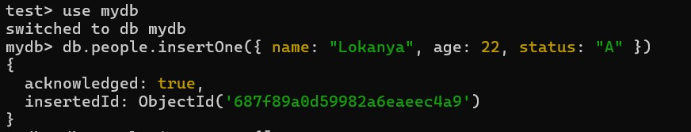

➤ Insert Multiple Documents:

db.people.insertMany([

{ name: "Alice", age: 25, status: "B" },

{ name: "Bob", age: 30, status: "A" },

{ name: "Charlie", age: 28, status: "C" }

])

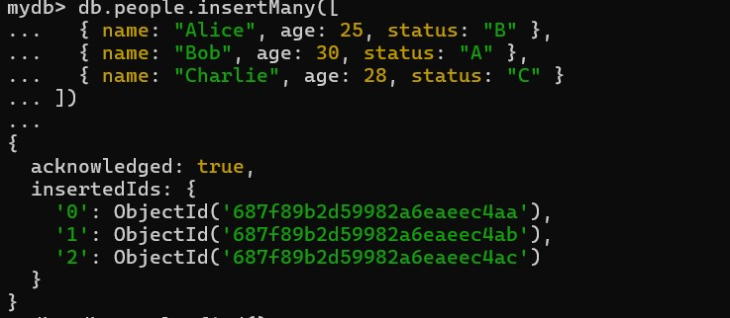

2. Finding Data

➤ Find All Documents:

db.people.find()

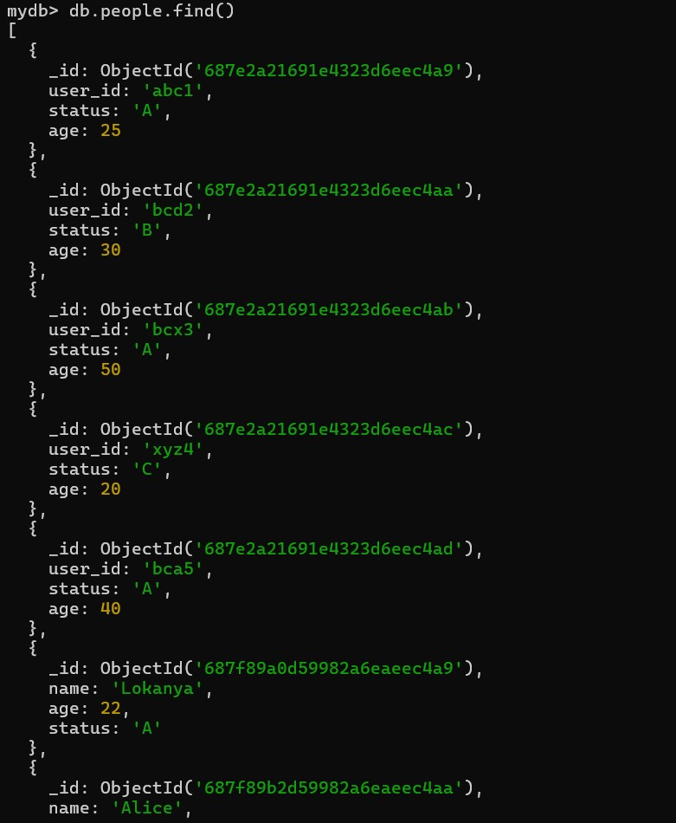

➤ Find with Filter:

db.people.find({ status: "A" })

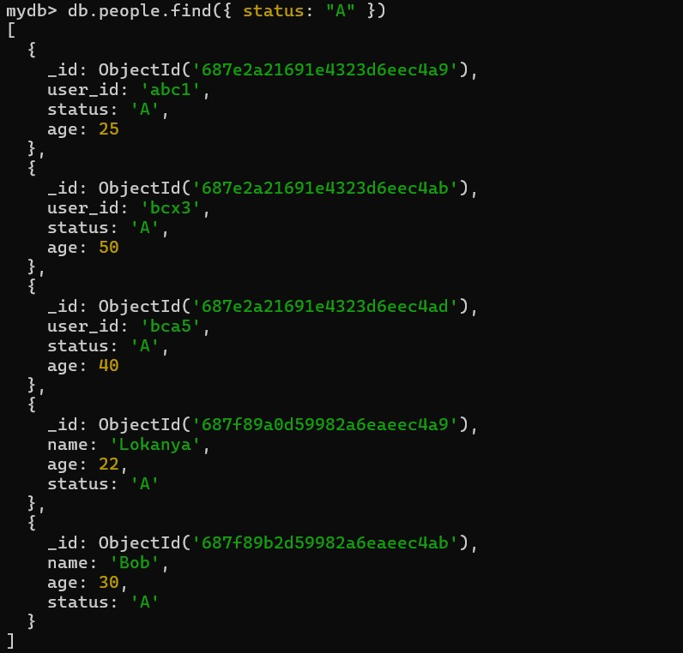

➤ Find Only One Document:

db.people.findOne({ name: "Alice" })

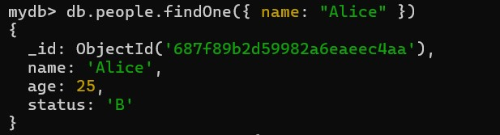

3. Updating Data

➤ Update One Document:

db.people.updateOne(

{ name: "Bob" },

{ $set: { age: 35 } }

)

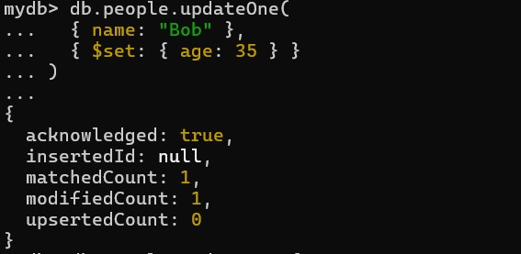

➤ Update Many Documents:

db.people.updateMany(

{ status: "A" },

{ $set: { active: true } }

)

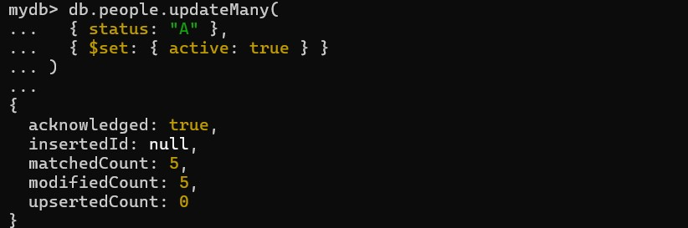

4. Deleting Data

➤ Delete One Document:

db.people.deleteOne({ name: "Charlie" })

➤ Delete Many Documents:

db.people.deleteMany({ status: "B" })

➤ Find and Delete One Document:

db.people.findOneAndDelete({ name: "Alice" })

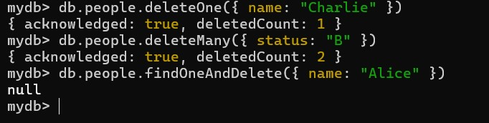

**Display only name and age**

db.people.find({}, { name: 1, age: 1 })

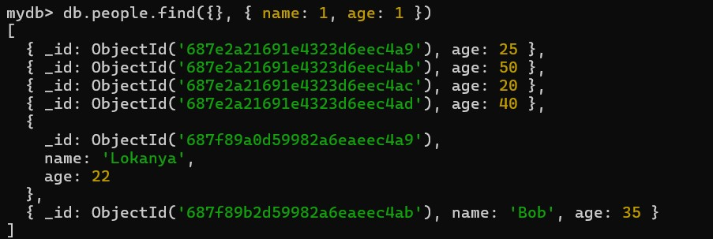

**Display name and age but exclude _id**

db.people.find({}, { name: 1, age: 1, _id: 0 })

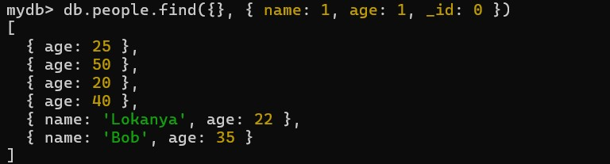

**Display name and status without _id**

db.people.find({}, { name: 1, status: 1, _id: 0 })

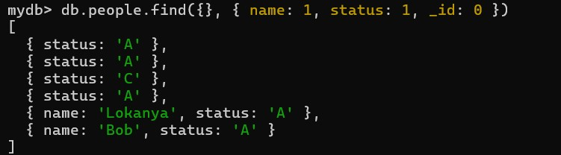

**Display name and status of people whose age is 25**

db.people.find({ age: 25 }, { name: 1, status: 1, _id: 0 })

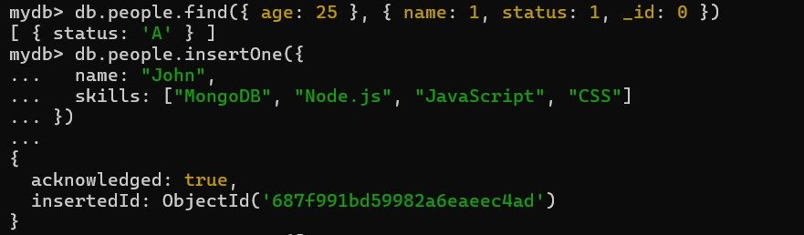

**Add Array Data to Use $slice and $elemMatch**

**Add One Document with skills Array:**

db.people.insertOne({

name: "John",

skills: ["MongoDB", "Node.js", "JavaScript", "CSS"]

})

**Use $slice to get first 2 skills**

db.people.aggregate([

{ $project: { name: 1, skills: { $slice: ["$skills", 2] } } }

])

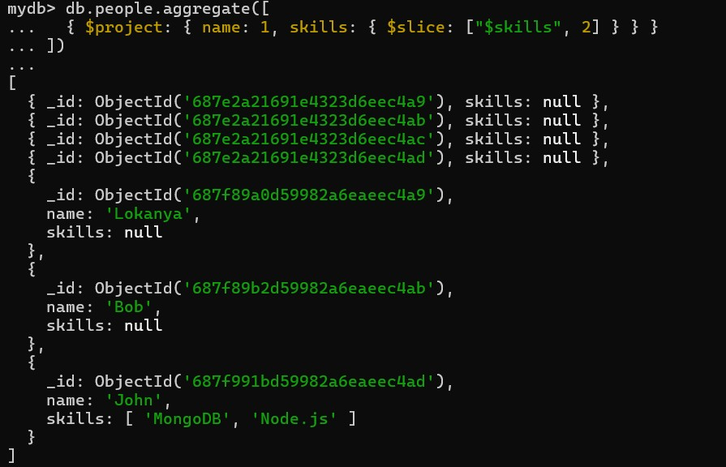

>> db.people.find({}, { name: 1, age: 1, _id: 0 })

